Dev Environment Setup and Git Exercise (100 Possible Points)
========================================================================
- Setup Dev Environment
**************************************************************************
- Follow the instructions from: https://github.com/rambasnet/DevEnvSetup
- Pick appropriate instructions according to your system and install the recommended tools:
  - Linux Bash Terminal
  - VS Code
  - git
  - g++, cmake
  - Jupyter Notebook with xeus-cling kernel
- Linux VM (requires more resources) or WSL (lightweight - requires fewer resources) is recommended if you use Windows

B. Complete Git-it Challenges
**************************************************************************
- Read the git-it README https://github.com/rambasnet/git-it-electron ; don’t follow the link on readme as it points to outdated stuff on jlord/git-it-electron repository. Complete the challenges by downloading the app from: https://github.com/rambasnet/git-it-electron/releases .
  - Note: if you’re using Windows, download Git Desktop for Windows from https://desktop.github.com/ and git-it app for Windows.
    - Make sure to download and install GitHub for Desktop.
    - Make sure to unzip the git-it app first and use the git-it app from the folder it’s extracted into. Don’t extract the app into another repository.
    - Use the git-bash program installed in step i to complete git-it challenges instead of WSL:Ubuntu.
  - On Branches Aren’t Just For Birds challenge:
    - Make sure to save the add-<USERNAME>.txt file in the CONTRIBUTORS folder in all caps inside the root Patchwork repo folder and NOT in the Patchwork/contributors subfolder.
    - Also make sure to add some contents like Hello in the text file.
  - Take the screenshot (as shown below) of the completed challenges that you need to add to your CS1-.. repository that you’ll create in the next step.
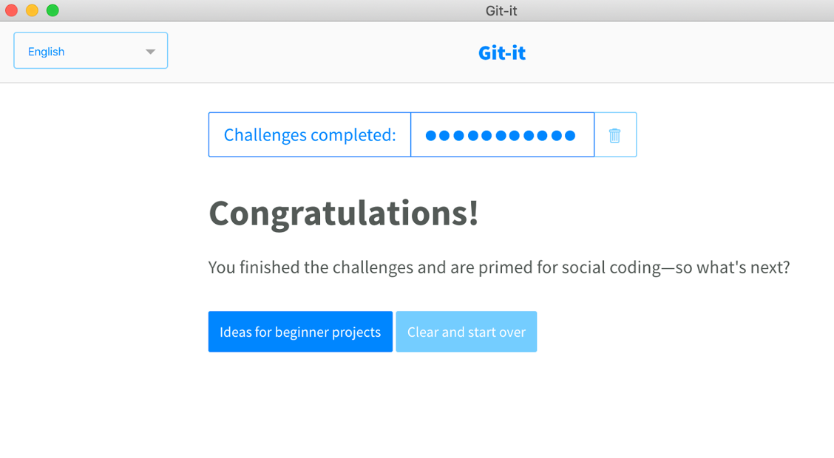

C. Create GitHub Repo for Labs and Assignments
**************************************************************************

You’ll use GitHub and the same repository created on GitHub to turn in all the assignments and labs for this class. Remember that you’ll need to create the repo only once!

- Login to github.com
- Create a new repository and name it: CS1-<your_mavzone_username>. E.g. CS1-rbasnet. This is your repository folder for this class wherein you’ll create project, assignments and labs specific folders to submit your work. NOTE:
  - You do this only once, unless your repository is somehow messed up or you want to work from a different system.
  - NEVER CLONE A REPO INSIDE ANOTHER REPO
  - $ cd <your desired folder>
  - $ git clone <paste your repository SSH url; ends with .git>
- Visibility Level should be private.
- Check “initialize repository with a README”.
- Add me (gtjames) as a collaborator into the repo.
  - Go to repository settings (cog icon) and click Collaborators. Add people -> Search gtjames and click add.
- Add a .gitignore file to ignore certain files such as npm packages, binary/exe, log, program and editor setting files, metadata files, local libraries, and modules that you may NOT need to track for the project. Choose C++ from the dropdown.
- Add SSH keys to authenticate your system; so you don’t have to use your username password all the time.
  - Can quickly test by running $ ssh -T git@github.com from a terminal. If authentication fails, follow the following instructions to create and add ssh keys.
  - Under profile settings, click key icon and go to SSH keys
  - Add a public key by generating a new one or existing one, see the specific links on that page for instructions or from this file: https://docs.google.com/document/d/1M0YeBfFPy5YPpfX7312R9-IldjagimvEma_YhgeLPcw/edit?usp=sharing

- Clone your CS1-<mav_username> repository to a computer you want to work from (git client must be installed on that computer). You do this only once, unless your repository is somehow messed up or you want to work from a different system.
  - $ git clone <paste your repository SSH url; ends with … .git>
- Fork CS1-Fundamentals to your GitHub account and clone it to your personal computer.
  - Note: Never clone a repository inside a repository folder.
- Open your CS1-<mav_username> repository cloned on your computer using VS Code or your favorite editor.
- Create this folder structure: assignments -> hellocs and do the following inside the hellocs subfolder.
  - create a new C++ file hello.cpp program that prints “Hello World!”
  - compile and run the hello.cpp program:
    - $ cd <hellocs folder>
    - $ pwd
      - Make sure the current working directory is … /assignments/hellocs
    - $ g++ hello.cpp
    - $ ./a.out
  - copy or drag and drop the screenshot of the completed git-it tutorial (git-it-screenshot.png) as shown above into the hellocs folder
  - $ git status
  - $ git add hello.cpp
  - $ git add git-it-screenshot.png
  - $ git commit -m “added 2 new files”
  - $ git push
  - $ git status

- Update README.md, follow this example of a demo student: https://github.com/rambasnet/csci000-astudent using Markdown code syntax provided here: https://github.com/adam-p/markdown-here/wiki/Markdown-Cheatsheet
- Make sure to add, commit and push local changes to the remote GitHub repository. Always double check to make sure the GitHub repository is up-to-date at github.com.
- Add your <git_username/repo_name> into this list: https://docs.google.com/document/d/1y7ujCHi4S5m150KFoDS4Qzvi85h4M1OvKg7J5A3npWY/edit?usp=sharing

